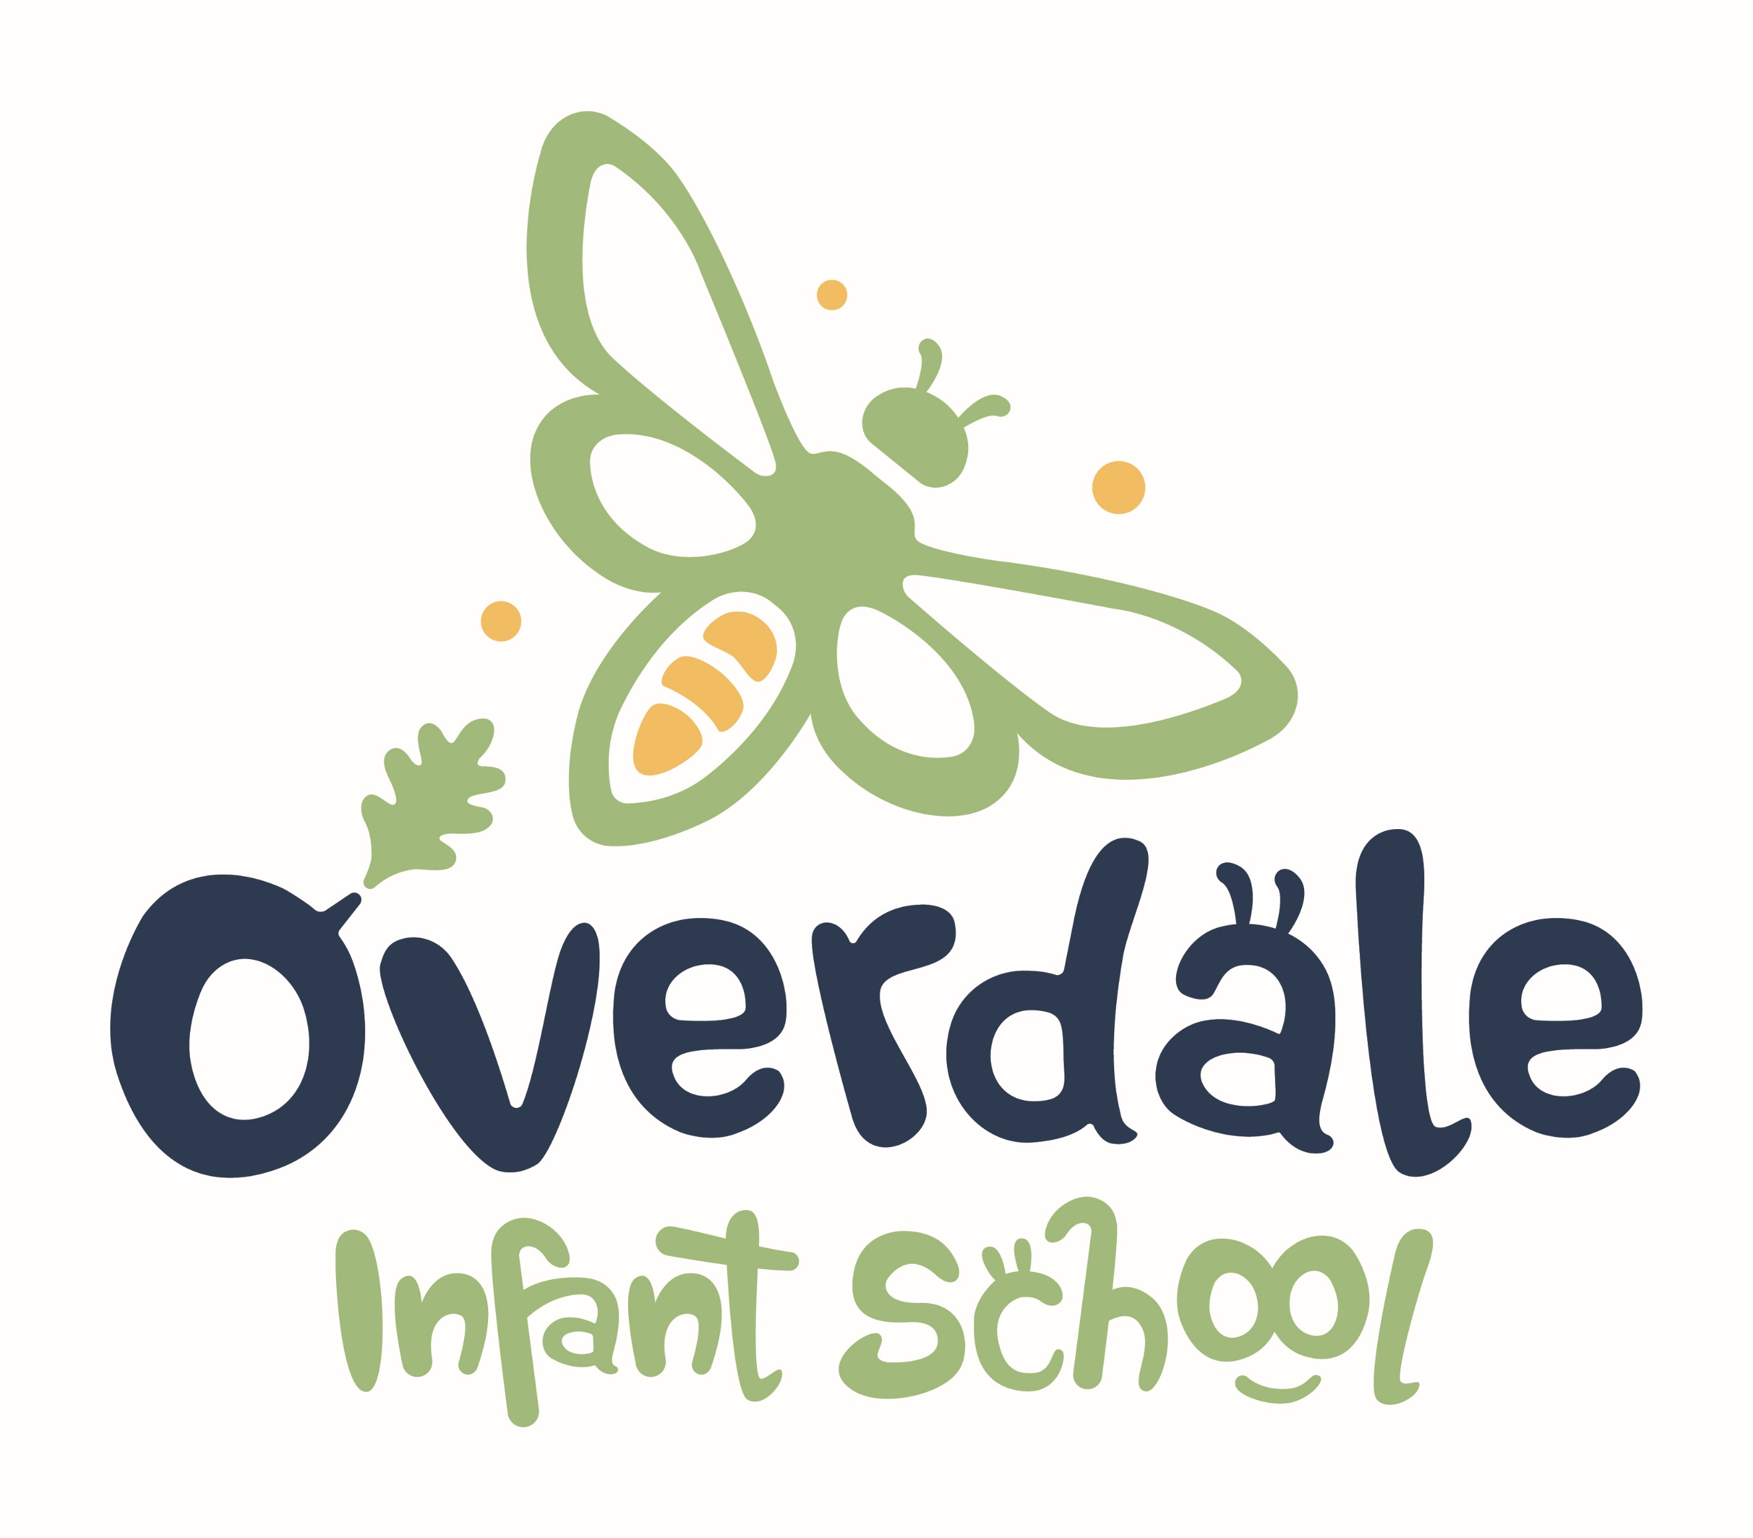
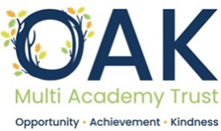
Music development plan summary:
Overdale Infant School

Overview
Detail | Information
Academic year that this summary covers | 2024-2025
Date this summary was published | November 2024
Date this summary will be reviewed | September 2025
Name of the school music lead | Sally Pridmore
Name of school leadership team member with responsibility for music (if different) | N/A
Name of local music hub | Leicestershire Music Hub
Name of other music education organisation(s) (if partnership in place) | N/A

This is a summary of how our school delivers music education to all our pupils across three areas
- curriculum music,
- co-curricular provision and
- musical experiences
and what changes we are planning in future years. This information is to help pupils and parents or carers understand what our school offers and who we work with to support our pupils’ music education.

Part A: Curriculum music
This is about what we teach in lesson time, how much time is spent teaching music and any music qualifications or awards that pupils can achieve.
At Overdale Infant School music is taught in all year groups from Pre School, Reception, Year 1, Year 2.
All children have access to the equivalent of 1 hour of music lessons a week, through a combination of classroom music, cross-curricular music and singing (in classrooms and/or in assemblies). In addition every year, children in Reception, Year 1 and Year 2 each learn and perform songs in a concert to the school and to parents.
At Overdale Infant School the music curriculum for Reception – Year 2 is based on teaching materials from the Kapow scheme of work, in line with the National Curriculum. The music curriculum for Pre School has been devised by staff to give children the relevant knowledge and experience prior to starting Reception.
Children in Reception join us from typically over 15 different providers, so not all of our children will have the same preschool experiences. We therefore begin Reception with opportunities for all children to be introduced to a variety of percussion instruments and explore music making and singing in class and via provision.
Lessons in each year group include opportunities for children to sing as a class, in smaller groups and individually. Lessons also provide children with opportunities to play instruments and perform as a class, in smaller groups or as an individual.
The music curriculum units taught are listed in the table below.
Pre School | Nursery rhymes and story songs  Different characteristics of music  Different sounds  Pitch  Sources which make sounds  Instruments
Reception | Music and continuous provision  Celebration music  Exploring sound  Music and Movement  Musical Stories  Big Band
Year 1 | Pulse  Tempo  Dynamics  Sound Patterns  Pitch  Musical Symbols
Year 2 | Call and Response  Instruments  Singing  Contrasting Dynamics  Structure  Pitch
Information on our music curriculum can be found here https://www.overdale-inf.leicester.sch.uk/page/?title=Music&pid=39
The units of work are adapted where necessary for children with SEND or additional needs. We use a range of scaffolds, reasonable adjustments and adaptive teaching strategies to support children across all subjects, a summary of which can be found on our website
Reasonable adjustments https://www.overdale-inf.leicester.sch.uk/_site/data/files/5D006B260454067FC15BDE5320C5F69F.pdf
Scaffold examples https://www.overdale-inf.leicester.sch.uk/_site/data/files/80667138DA36B5481245CFBB5B450B02.pdf

The music lead at Overdale Infant School has had initial contact with Leicestershire Music Hub and as a school we are beginning to explore how we can integrate the support of the Music hub with our Kapow based curriculum.

Part B: Extra-curricular music
This is about opportunities for pupils to sing and play music, outside of lesson time, including choirs, ensembles and bands, and how pupils can make progress in music beyond the core curriculum.
At Overdale Infant School there is a school choir which is open to pupils in Year 2 (Y1 in the summer term). It takes place during playtime each week to allow all pupils to access it if they wish. It is run by a group of staff including the current music coordinator, previous music coordinator and the head teacher. It is free to join choir. Pupils learn songs as well as practise vocal warm-ups, learn about pitch, timing and performance skills. Where possible, performance opportunities are available through school, e.g in school assemblies, visiting local care homes at Christmas, performing at the school fete.
(When children move to KS2 at Overdale Junior School, piano lessons are available to individuals and percussion lessons are available in small groups or individually to children in year 3 and above.)
In 2004-25 we plan to explore further opportunities for extra-curricular music that can be offered to our pupils on site, in connection with Leicestershire Music Hub and other providers. We will ensure some places are available for pupil premium children and look to support with any costs. We also plan to explore extra curricular music opportunities available locally and publicise these to parents.

Part C: Musical experiences
This is about all the other musical events and opportunities that we organise, such as singing in assembly, concerts and shows, and trips to professional concerts.
At Overdale Infant School, Pre-school and Reception children incorporate music and singing to support all areas of learning, this includes learning new songs, responding to music, moving to music, musical opportunities in provision (indoors and outdoors) singing as part of collective worship in classrooms.
KS1 children have weekly singing assemblies lead by one of our assistant head teachers, where they practise skills, learn new songs and performance techniques.
Lunchtime supervisors provide opportunities for children to listen and respond to different kinds of music in the playground at lunchtime.
We have an annual Arts Week during which children have opportunities to listen and respond to music through art.
Children take part in an annual performance that includes, music, singing, dancing or poetry and readings.
Reception – Christmas production
Year 1 – Spring Festivals production
Year 2 – Leavers’ production
Typically there are 3 performances – one to the rest of the school (preschool are invited to the Reception production), and two performances for parents and carers.
Across the year each class performs their own class assembly to their year group alongside their parents and carers.
At Christmas, children visit St Mary’s Church for a church service. Due to the capacity of the church, there is one service for Pre-school and Reception, and one service for KS1. Parents are invited to attend and hear the children perform a mixture of traditional and modern Christmas songs.
At Overdale Infant School this year, children will have opportunities for linked musical activities with other trust schools (currently at the planning stage with the trust music leaders).
Every year our children have the opportunity to visit a theatre in Leicester to experience live performances, this takes place during December each year. This is available to all children at a cost to parents, with school covering the costs for children eligible for Pupil Premium.
During the year, our children are able to experience performances from visiting groups from Overdale Junior School, including choir visits and musicians. We have recently linked with members of the Leicester Symphony Orchestra who have performed to the children in assembly.

In the future
This is about what our school is planning for subsequent years.
Here are the ways that we plan to develop our Music provision in 2024-25 and beyond.
As a school we will continue to meet and work with music leaders from OAK Trust schools and consider how to use the support of Leicestershire Music Hub.

Curriculum
● KS1 staff to trial, monitor and provide feedback on the revised timetabling of music and the impact on other foundation subjects.
● Staff to trial, monitor and provide feedback on the new KS1 units of work based on updated Kapow scheme of work.
● Adapt medium term plans and knowledge organisers as necessary.
Directly linked to all curriculum areas on our SDP-
● Retrieval practice of topics to be sequenced to ensure that spacing is planned to support knowledge acquisition.
● Ensure all children, including those with SEND and other diverse learning needs, can access the curriculum through the effective use of reasonable adjustments and adaptive teaching strategies (e.g., scaffolds, scale, structure, and style).
● Ensure challenge is available in lessons for more able children, as appropriate.

Assessment
● Monitor and review the use of and effectiveness of assessment criteria on medium term plans.
● Monitor how evidence of music is collected in order to demonstrate progress.

Extra-curricular
● Consider the scope to provide a Lunchtime Music Club. Include opportunities for children from the Club to perform in an assembly.
● Investigate the scope for extra-curricular opportunities, particularly instrument based (externally run).
● Develop musical activities with other OAK trust school.

Live Performances and workshops
● Make further links with members of the community and with other schools to widen the opportunities for children to experience performances from older children and musicians.

Resources
● Review our instruments stock - what is used well, what is rarely used, what else could we benefit from?

Further information
The government has published the following document which sets out their vision for music education national plan for music education:
The Department for Education publishes a guide for parents and young people on how you can get involved in music in and out of school, and where you can go to for support beyond school.

And finally…
What do our children say about music at Overdale Infant School?
