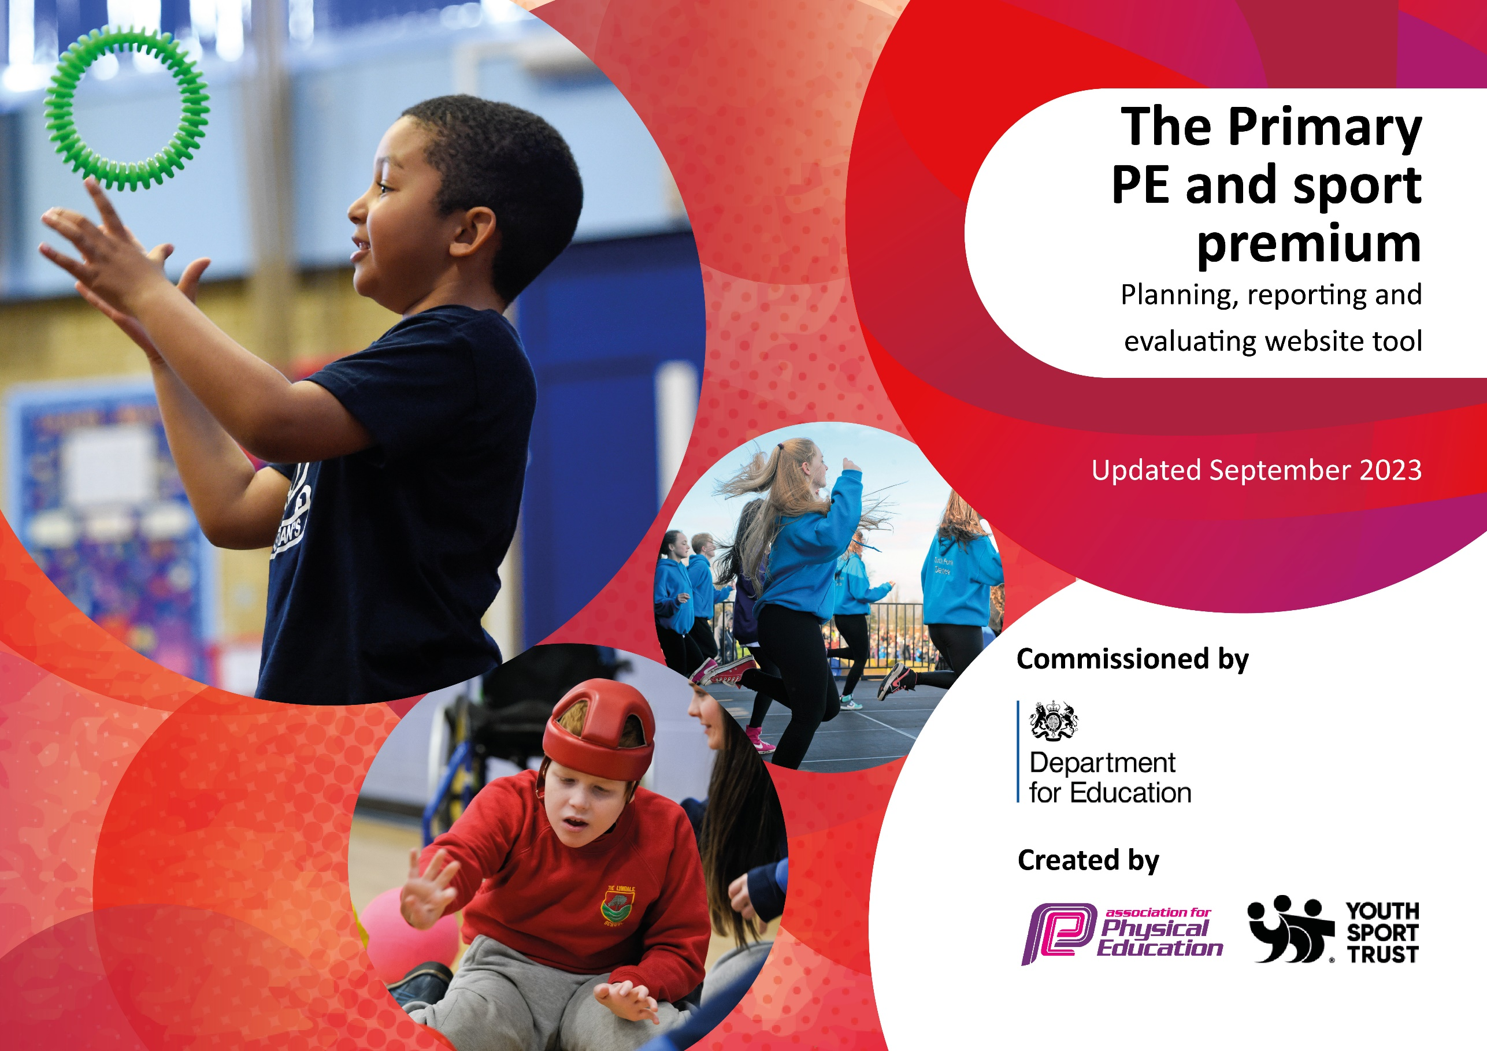

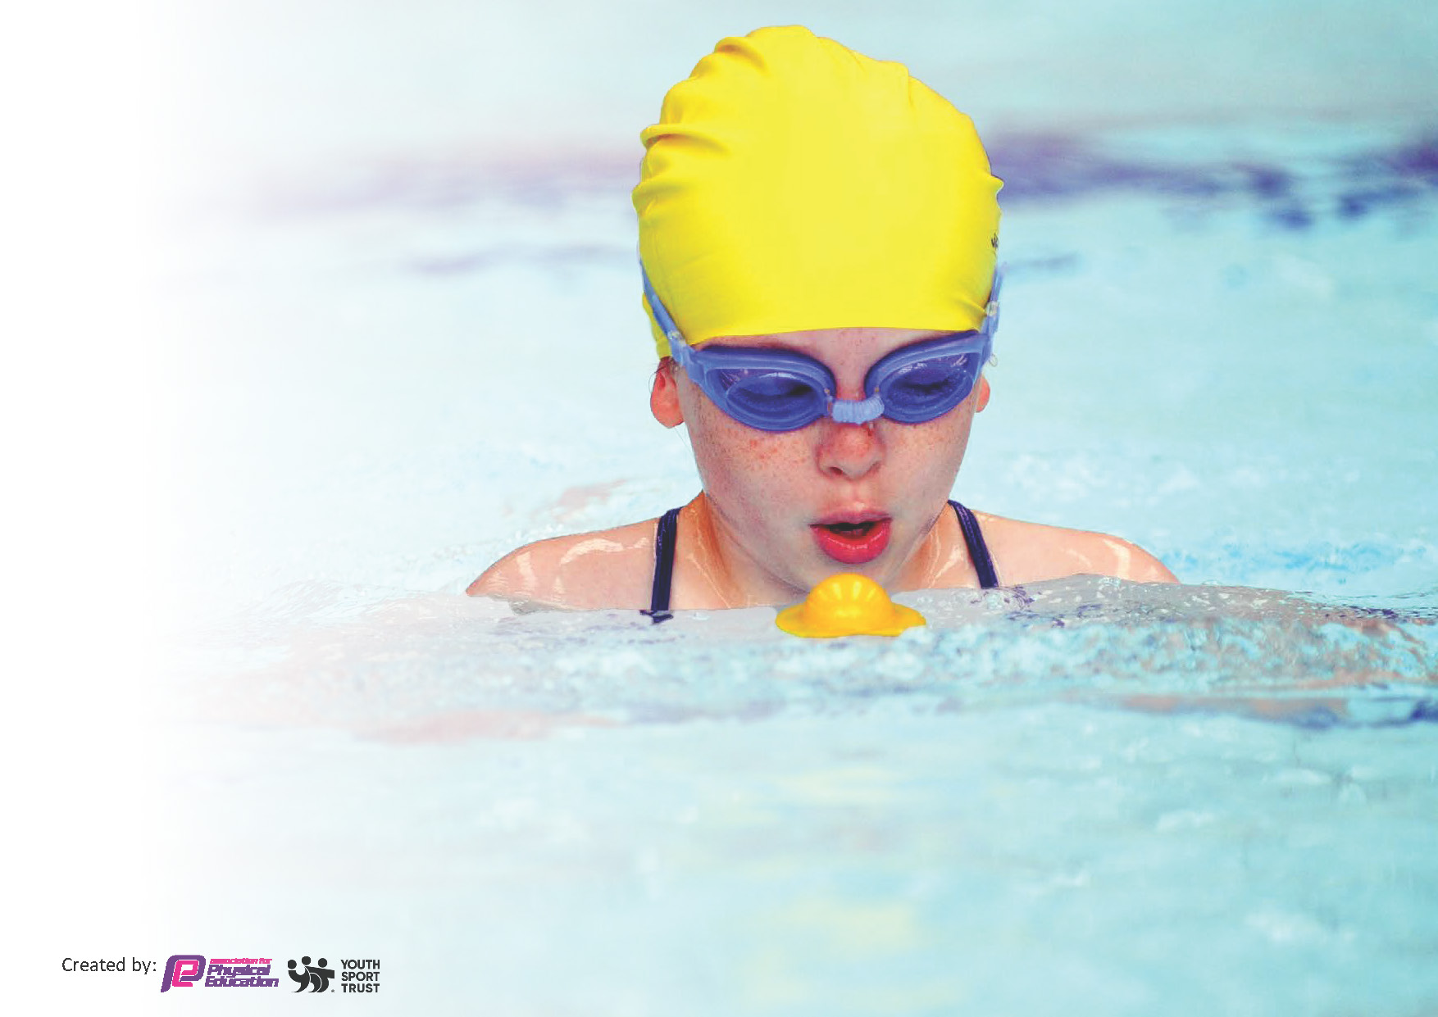
This template can be used for multiple purposes:
by:
- It enables schools to effectively plan their use of the Primary PE and sport premium
- It helps schools to meet the requirements (as set out in guidance) to publish information on their Primary PE and sport premium
- It will be an effective document to support Ofsted inspections enabling schools to evidence progress in Physical Education (PE) and evidence swimming attainment, which forms part of the PE National Curriculum. We would recommend schools consider
the Intent, Implementation and Impact of any spend, as examined within the Education Inspection Framework.

It is important that your grant is used effectively and based on school need.

Schools must use the funding to make additional and sustainable
improvements to the quality of the PE, School Sport and Physical Activity (PESSPA)
they offer. This means that you should use the Primary PE and sport premium to:

- Build capacity and capability within the school to ensure that improvements made now will benefit pupils joining the school in future years
- Develop or add to the PESSPA activities that your school already offers.

The Primary PE and sport premium should not be used to fund capital spend projects; the school’s core budget should fund these. Further detail on capital expenditure can be found in the updated Primary PE and sport premium guidance.

The Primary PE and sport premium guidance, outlines 5 key priorities that funding should be used towards. It is not

necessary that spending has to meet all the key priorities, you should select the priorities that you aim to use any funding towards.

Although completing this template is not a requirement for schools, schools are required to publish details of how they spend this funding. Schools must also outline what the impact this funding has had on pupils’ PE and sport participation and attainment and how any spending will be sustainable in the future. All funding must be spent by 31st July 2024.

The Department for Education has worked closely with the Association for Physical Education (afPE) and the Youth Sport Trust (YST) to develop this template and encourages schools to use it. This template is an effective way of meeting the reporting requirements of the Primary PE and sport premium.
Review of last year’s spend and key achievements (2022/2023)

We recommend you start by reflecting on the impact of current provision and reviewing your previous spend.

Activity/Action | Impact | Comments
Happy lunch time equipment brought and to be used at lunch time.  Metcalf coaching carrying out sporting activities on the playground during lunch times.  Activall Board Annual Rental  Diddi Dance sessions have been carried out to support gross and fine motor skills for SEN children.  Active breaks and bursts to be developed in classrooms/outside and during continuous provision. | Children are a lot more active during lunch times. It has impacted the behaviour on the playground with less incidents.  Less first aid issues as children have developed their co-ordination, know how to play teams games and children have more special awareness.  Children are developing a love for a sport/activity which therefore, is making children more active.  EYFS children have developed their spatial awareness, co ordination and gross motor skills. | Happy lunch times and Metcalf sports coach will continue next year. Metcalf sports coach will carry out more sporting clubs at lunch. This will impact children’s sporting interests.

Key priorities and Planning
This planning template will allow schools to accurately plan their spending.

Action – what are you planning to do | Who does this action impact? | Key indicator to meet | Impacts and how sustainability will be achieved? | Cost linked to the action
To offer a broad and balanced curriculum helping to raise achievement and attainment in PE. | Class teachers, sports coaches and support staff across the school.  GetSet4PE has been purchased, as this is something we want to follow for our planning to build up a broad and balanced curriculum.  Children will be impacted by participating in a range of sporting activities. | Children are getting their regular activity following the guidelines. Children are enjoying PE lessons. Broader experience of a range of sports and activities offered to all pupils. | Curriculum will now be appropriately sequenced and there is no repetition of units and skills build up over time. Core strength is beginning to improve and children’s stamina has improved due to regular movement breaks. Progression of skills document for PE has been completed. Staff can now see where children are and what they need to do for each year group.  Whole school attainment improves. School community understands the importance of high-quality PE. | £3366

CPD for staff and teachers.  Diddi Dance (SEN provision) | GetSet4PE provides staff with lesson plans that can be adapted and provides staff with CPD videos.  Metcalf sports coach to support teachers teaching PE and key pointers given to staff by the coach.  Diddi Dance was used with SEN children to support with big moves. This supported staff with activities in the classroom as well. | SEND children were getting regular exercise and movement. Supported with low level disruption in the classroom. Gave SEN children a range of movement/dance experience. | Teachers and staff with feel confident to teach PE. Teachers and staff will begin to enjoy teaching PE with the correct equipment and knowledge. | 2,970.00 (Feb)  1,881.00 (March)  3,366.00 (May)  2,871.00 (July)  GetSet4PE =  408.00  200.00

Key achievements 2023-2024
This template will be completed at the end of the academic year and will showcase the key achievements schools have made with their Primary PE and sport premium spending.

Activity/Action | Impact | Comments
GetSet4PE has been purchased and used at the end of the academic year. Trialed by staff and ready to use next year. All staff have access to GetSet4PE planning.  CPD for teachers  Happy lunch time equipment and Metcalf coach supporting with active lunch times. | All staff know where PE planning has come from. Staff have access to CPD to support teaching for PE. Staff in school have confidence on how to teach PE.  CPD videos and resources for GetSet4PE for staff to build up their knowledge and confidence to teach PE.  Children are active at playtime and less behaviour issues in school.

Swimming Data
Meeting National Curriculum requirements for swimming and water safety.
Priority should always be given to ensuring that pupils can perform safe self-rescue even if they do not fully meet the first two requirements of the National Curriculum programme of study

Question | Stats: | Further context  Relative to local challenges
What percentage of your current Year 6 cohort can swim competently, confidently and proficiently over a distance of at least 25 metres? | N/A | N/A
What percentage of your current Year 6 cohort can use a range of strokes effectively [for example, front crawl, backstroke, and breaststroke]? | N/A | N/A

What percentage of your current Year 6 cohort are able to perform safe self-rescue in different water-based situations? | N/A | N/A
If your schools swimming data is below national expectation, you can choose to use the Primary PE and sport premium to provide additional top-up sessions for those pupils that did not meet National Curriculum  requirements after the completion of core lessons. Have you done this? | N/A | N/A
Have you provided CPD to improve the knowledge and confidence of staff to be able to teach swimming and water safety? | N/A | N/A

Signed off by:

Head Teacher: | (Name)
Subject Leader or the individual responsible for the Primary PE and sport premium: | Lydia Ashton
Governor: | (Name and Role)
Date: | 27/06/24

