Overdale Infant School
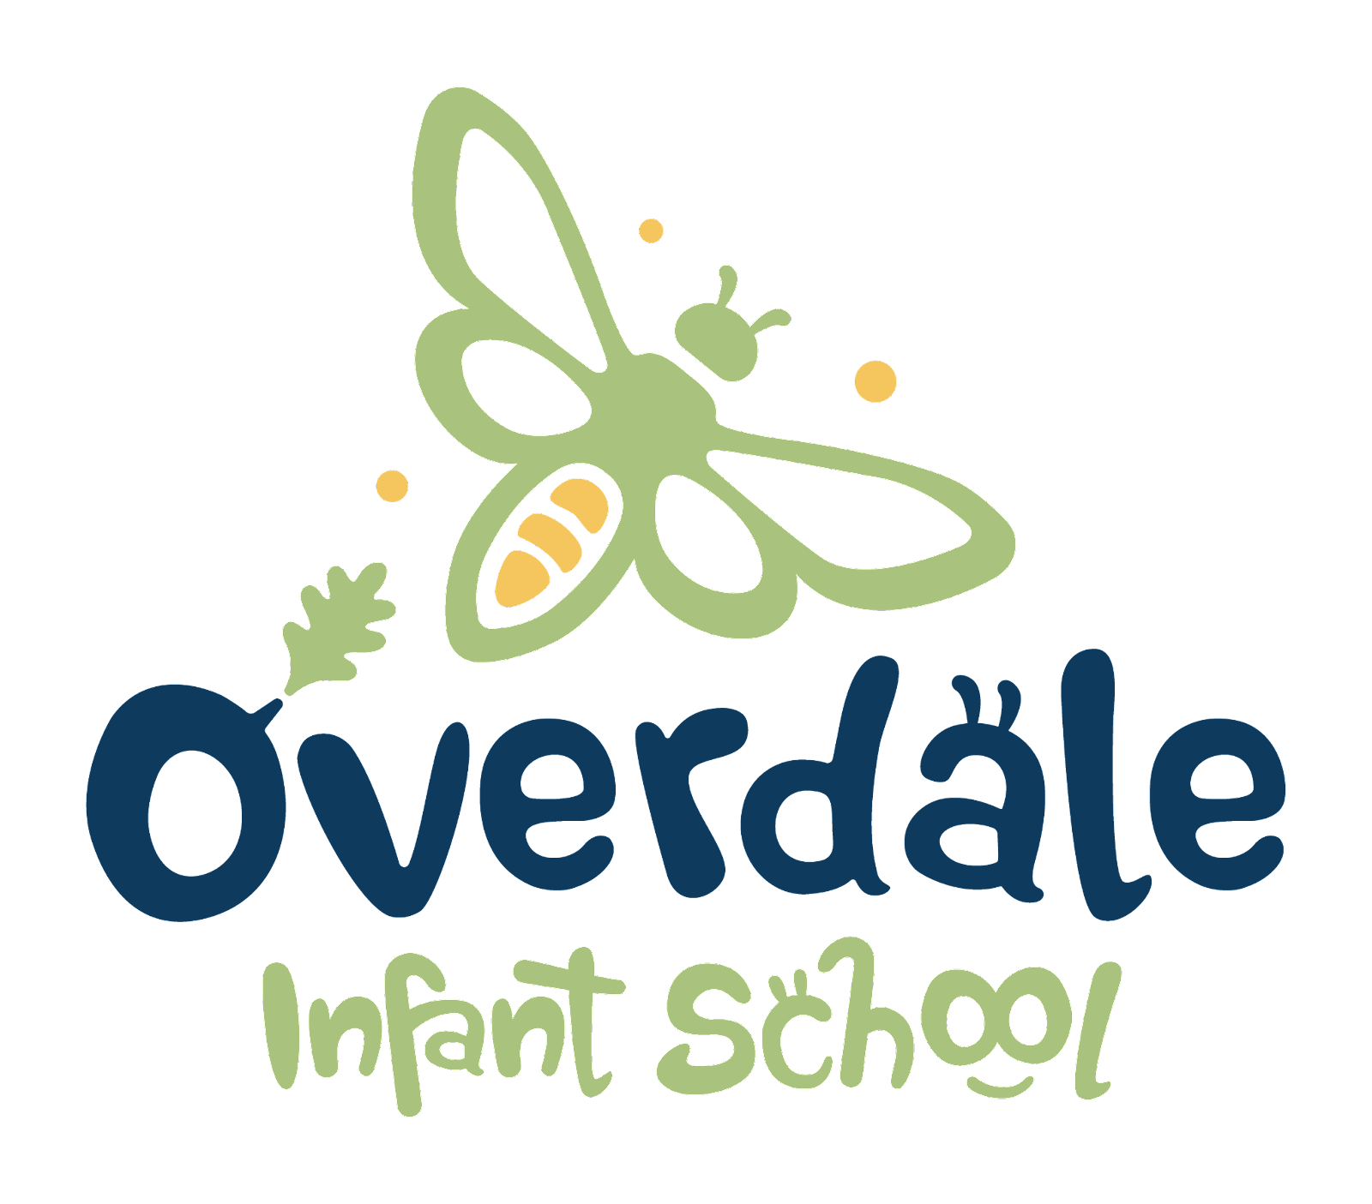
Equalities Policy
(including equalities objectives 2022-2024)

Policy Date: | November 22 | Version | V1
Policy Review Date: | November 24 | Headteacher  Hayley Holmes | Hayley Holmes
Ratified by Governing Body: |  | Matt Davis | Matt Davis

Contents
1. Equality Statement 1
2. Legal Duties 1
3. Guiding Principles 3
4. Definitions 4
5. Roles and Responsibilities 5
6. Monitoring and Reviewing 6
7. Equal opportunities for Staff 6
8. Complaints 7
9. Equality Objectives 7
10. Behaviour, Exclusions and Attendance 10
11. Links to other documents 10
12. Useful Links 10

1. Equality Statement
Overdale Infant School wants to be recognised as a school at the heart of our community, providing an inclusive, safe, caring and stimulating environment in which to learn.
At Overdale Infant School, we are committed to ensuring equality of education and opportunity for all pupils, staff, parents, and carers receiving services from the school, irrespective of race, gender, disability, faith or religion or socio-economic background. We aim to develop a culture of inclusion and diversity in which all those connected to the school feel proud of their identity and able to participate fully in school life.
The achievement of pupils will be monitored by race, gender and disability and we will use this data to support pupils, raise standards and ensure inclusive teaching. We will tackle discrimination by the positive promotion of equality, challenging bullying and stereotypes and creating an environment which champions respect for all. At Overdale Infant School, we believe that diversity is a strength, which should be respected and celebrated by all those who learn, teach, and visit here.

2. Legal Duties
At Overdale Infant School we welcome our duties under the Equality Act 2010. The general duties are to:
- eliminate discrimination harassment and victimisation
- advance equality of opportunity between those people who share protected characteristics and those who do not
- foster good relations between different people when carrying out their activities to promote community cohesion.
We understand the principal of the act and the work needed to ensure that those with protected characteristics are not discriminated against and are given equality of opportunity. Protected characteristics make up the part of a person’s identity that makes them who they are, such aspects or characteristics are protected from discrimination. Everyone in Britain is protected from unlawful behaviour by the Act.
The protected characteristics are as follows:
- age
- disability
- race
- sex
- gender reassignment
- maternity and pregnancy
- religion and belief
- sexual orientation
- marriage and civil partnership (for employees)

We recognise that these duties reflect international human rights’ standards as expressed in the UN Convention on the Rights of the Child, the UN Convention on the Rights of People with Disabilities, and the Human Rights Act 1998. In developing our policy, we have therefore also taken them into consideration.
To meet our general duties, listed above, the law requires us to carry out some specific duties to demonstrate how we meet the general duties
These are to:
- Publish Equality Information – to demonstrate compliance with the general duty across its functions (We will not publish any information that can specifically identify any individual)
- Prepare and publish equality objectives which we will review on an annual basis
- Consult all our stakeholders in the development of our equality objectives and report on progress against our objectives on an annual basis
To do this effectively we will collect data related to the protected characteristics above and analyse this data to determine our focus for our equality objectives. The data will be assessed across our core provisions as a school, but we will also analyse available data relating to the context of our local community, including hate crime data and demographic information. In relation to school provision, we will pay particular attention to the following functions:
- Admissions
- Attendance
- Attainment
- Exclusions
- Prejudice-related incidents
- Curriculum
- Complaints/compliments
Our objectives will detail how we will ensure equality is applied to the services listed above, however where we find evidence that other functions have a significant impact on any group, we will include work in this area.
We also recognise that our work on equality is central to the successful promotion of fundamental British values, especially in relation to the values of respect and tolerance and the rule of law. We will therefore ensure that our curriculum helps to prepare pupils for life in modern Britain. We will work proactively to address all forms of prejudice and discrimination, including derogatory and discriminatory language. We will mainly do this through the delivery of our statutory RSE / PSHE Curriculum. We will also utilise all other subject areas to foster positive relations and to ensure that we consciously cultivate opportunities to challenge stereotypes and support positive identity development for all our pupils.
We will regularly audit our resources, displays, lesson content, and assessment processes to ensure that they meet the needs of all groups. We will scrutinise outcomes across a range of measures, analyse the results and address any identified areas of concern.
In endeavouring to fulfil our legal duties, we will:
- Recognise and respect diversity
- Foster positive attitudes and relationships, and a shared sense of belonging
- Observe good equalities’ practice, including staff recruitment, retention, and development
- Aim to identify, reduce, and remove existing inequalities and barriers
- Consult and involve widely
- Regularly review our progress

3. Guiding Principles
In fulfilling our legal obligations and best practice aspirations, we are guided by nine principles:
- all pupils, their parents and carers, are of equal value;
- we recognise and respect difference - treating people equally does not mean treating everyone the same. Equality is about fair treatment and sometimes people have to be treated differently in order to make sure that things are fair;
- we foster positive attitudes and relationships and a shared sense of cohesion and belonging;
- we observe best equalities practice in staff recruitment, retention and development;
- we aim to reduce and remove inequalities and barriers that already exist;
- we consult and involve widely.
- we intend that society as a whole should benefit from our policies and activities, promoting greater social cohesion and participation in public life;
- we base our practices on sound evidence and information; and
- we formulate and publish our equality objectives at least every four years and our accessibility plan is reviewed at least every three years.
In practice, this means assessing the implications for people with particular protected characteristics when deciding; considering equality implications when developing policy and taking action; and integrating the public sector equality duty into the carrying out of our functions. In doing this, we keep each curriculum subject and teaching strategy under review to ensure that teaching and learning reflect the guiding principles set out above. We also seek to evidence the application of these principles in:

- Pupils’ progress, attainment and achievement
- Pupils’ personal development, welfare and well-being
- Teaching styles and strategies
- Admissions and attendance
- Staff recruitment, retention and professional development
- Care, guidance and support
- Behaviour, discipline and exclusions
- Working in partnership with parents, carers and other agencies
- Partnership working with the wider community
- The publication of our equality objectives and accessibility plan

Overdale Infant School is opposed to all forms of prejudice, bullying and harassment. We have a range of policies and procedures which set out how incidents should be identified, recorded, addressed and resolved. We monitor and report on such incidents.
We respect the religious beliefs and practices of all staff, parents and pupils and comply with reasonable requests relating to religious observances and practice.

4. Definitions
Discrimination is unfair treatment towards another or a group of individuals who share one or some of the protected characteristics.
Direct Discrimination occurs when someone is treated less favourably than others because of a protected characteristic.
Discrimination by Association occurs when someone is treated less favourably because someone they are associated with, such as a friend, family member or carer, has a protected characteristic.
Direct Discrimination by Perception occurs when someone is treated less favourably because someone believes they have a protected characteristic, regardless of whether their perception is correct or not.
Indirect discrimination can be more difficult to identify and sometimes is not intended. It can occur due to a lack of understanding of the law or a genuine error of judgement about an individual. For example, a policy that is applied to all individuals equally may inadvertently disadvantage individuals or groups who have a protected characteristic. It is therefore essential that all aspects of school life and policies are scrutinised carefully to avoid any unlawful provision, criterion, or practice.
Victimisation occurs when an individual has either raised a complaint or grievance that they have been discriminated against based on having a protected characteristic; or has supported someone who has raised a complaint or grievance.
Harassment is any form of unwanted behaviour intended to violate an individual’s dignity or create an environment which may be described as hostile, degrading, humiliating or offensive. The victim will be subject to this harassment based on a protected characteristic or the perception that they have a protected characteristic, or because they are associated with someone who has a protected characteristic.
Prejudice can be conscious or unconscious and involves stereotypes, prejudgments, and beliefs (which are usually negative) about an individual, or group of people, based on a protected characteristic.

5. Roles and Responsibilities
The OAK Multi Academy Trust
The MAT is responsible for ensuring that the school complies with legislation and all Trust wide policies. They also review all data with regard to attainment, progress, attendance and behaviour.
The Governing Body
The school’s governing body (along with the MAT) ensures that this policy and its related procedures and action plans are implemented. The MAT and governing body committee keeps aspects of the school’s commitment to the Equality Duty under review, for example, in terms of standards, curriculum, admissions, exclusions, personnel issues and the school environment. Equalities objectives are set every four years by the school.
The Headteacher
The Headteacher is responsible for implementing the policy; for ensuring that all staff are aware of their responsibilities and are given appropriate training and support; and for taking appropriate action in any cases of unlawful discrimination and reporting these as appropriate.
Teaching and Support Staff
All teaching and support staff will:
- promote an inclusive and collaborative ethos in their classroom
- challenge prejudice and discrimination
- deal fairly and professionally with any prejudice-related incidents that may occur
- plan and deliver curricula and lessons that reflect the school’s principles, for example, in providing materials that give positive images in terms of race, gender and disability
- maintain the highest expectations of success for all pupils irrespective of race, religion, gender, economic background, disability etc.
- support different groups of pupils in their class through differentiated planning and teaching, especially those who may (sometimes temporarily) find aspects of academic learning difficult
- keep up-to-date with equalities legislation relevant to their work.
- Deliver our Personal Development curriculum which encompasses RSHE and PSHE objectives.

Visitors
All visitors to the school, including parents and carers are expected to support our commitment to equalities and comply with the duties set out in this policy. We will publish this policy on our website to enable them to do this.

6. Monitoring and reviewing
We review the information about equalities in the policy every four years and make adjustments as appropriate. Further amendments may occur with changes in legislation or as the need arises.
The Governing Body is responsible for ensuring that the school complies with legislation and that this policy, procedures and related actions are implemented. We identify a specialist governor with responsibility for equalities who ensures this policy is fully implemented.
The Head Teacher and Senior Leadership Team (SLT) are responsible for implementing the policy and for ensuring that all staff are aware of their responsibilities, given appropriate training and support, and for taking action in respect of this policy.

All staff are expected to:
- promote an inclusive and collaborative ethos;
- deal with any prejudice related incidents as they occur;
- plan and deliver curricula that reflect the principles above;
- support those pupils and families for whom English is an additional language; and
- keep up to date with equalities legislation relevant to their work.

The following should also be noted:
- Breaches of this policy will be dealt with by the formal procedures laid down.
- We collect and analyse data in relation to achievement, broken down according to some of the protected characteristics.
- The promotion of community cohesion is integrated into this policy.
- The wording of this policy in certain places reflects the duties of the Act.

7. Equal Opportunities for Staff
This section deals with aspects of equal opportunities relating to staff. We are committed to the implementation of equal opportunities principles and the monitoring and active promotion of equality in all aspects of staffing and employment.
- All staff appointments and promotions are made on the basis of merit and ability and in compliance with the law.
- We are also concerned to ensure wherever possible that the staffing of the school reflects the diversity of our community.
- As an employer our Trust strives to ensure that we eliminate discrimination and harassment in our employment practice and actively promote equality across all groups within our workforce.
- We respect the religious beliefs and practice of all staff, pupils and parents, and comply with reasonable requests relating to religious observance and practice.
- We ensure that all staff, including support and administrative staff, receive appropriate training and opportunities for professional development, both as individuals and as groups or teams.

8. Complaints
Complaints arising from the operation of this policy will be dealt with in line with the JOAK Multi Academy Trust’s complaints procedure

9. Equality objectives 2022-2024
The Equality Objectives of Overdale Infant School have been identified by the school in order to take action against all forms of inequality and to address all forms of disadvantage and discrimination wherever it may exist.
- Raise the achievement of boys in Maths at the end of Year 2 in order to close the gender gap.
- Ensure that the achievement (progress) of children from vulnerable and disadvantaged families (Pupil Premium) improves so that it is in line with or above that of all non-disadvantaged children.
- Promote the understanding of and respect for difference within the school and its community.
- Ensure equality of access to all aspects of our curriculum and school provision (buildings and extended services)

Objective | Main Actions | Lead Person | Timescales | Evidence of Impact
- Raise the achievement of boys in Maths at the end of Year 2 in order to close the gender gap.  (Current Year 1 cohort) | Data and test level analysis to identify key issues for boys’ achievement in Maths in Year 2.  Progress Meetings track attainment and next steps for teaching and learning.  Monitoring by SLT and Maths Lead identifies strengths and development points to improve Maths provision for boys (currently in Year 1) | HT  DHT  English Lead  Writing Lead | July 2024 | Records of Progress Meetings and monitoring  Data: in-school and end of KS1 2024
2. Ensure that the achievement (progress) of children from vulnerable and disadvantaged families (Pupil Premium) improves so that it is in line with or above that of all non-disadvantaged children. | Data and test level analysis to identify key issues for Pupil Premium group.  Pupil Progress Meetings track attainment and next steps for teaching and learning.  High quality interventions in place with clear timelines and evaluations to ensure impact.  Pupil Premium plan is reviewed at least annually to ensure impact of budget on attainment | Strategic lead for Pupil Premium Paula Coplin | July 2024 | Records of Progress Meetings, intervention evaluations and monitoring  Data: in-school and end of KS1
Promote the understanding of and respect for difference within the school and its community. | Behaviour policy and systems promote respect for differences and equality.  Assemblies, school events, visits and visitors reflect the whole community and British values.  Planned community/ parent participation in surveys and consultations e.g. SRE consultation.  Ensure high quality provision and resources in PSHE/ RE/ P4C lessons which develop and challenge understanding of difference and equality in the community and wider world.  Expectations and monitoring of the learning environment and resources to ensure that it reflects the community including book choices, SEND provision and achievement. | HT  DHT  Equality and Diversity Lead  Hazra Giga | January 2024 | Low or reducing incidents of racism/ discriminatory behaviours  Curriculum map/ planning  Policy and practice which reflect consistent approach to school ethos and equality
Leaders ensure equality of access to all aspects of our curriculum and school provision by ensuring pupils with SEND receive scaffolds and support where needed. | Accessibility Plan is in place and reviewed regularly.  Survey of after school clubs and family learning to ensure being accessed by all groups in the school including Pupil Premium, SEND. Action plan to improve accessibility and focus where required.  Subject Leads review and update resources to ensure equality of access e.g. PE equipment.  SENDCo and SLT members monitor the progress of pupils with SEND to ensure they are making at least average progress. | HT  DHT  Designated teacher for looked after children  Paula Coplin  SENDCo  Natalie Howard | March 2024 | Disability and Accessibility Plan  Extended school records/ tracking  Subject Lead budget tracking/ action plans

10. Behaviour, Exclusions and Attendance
The school and MAT’s policies on Pupil Discipline & Anti-Bullying and Attendance take full account of the new duties under the Equality Act. We make reasonable, appropriate and flexible adjustment for pupils with a disability. We closely monitor data on exclusions and absence from school for evidence of overrepresentation of different groups and take action promptly to address concerns.

11. Links to other documents
Please also see:
- Behaviour and Anti-bullying policy
- SEND policy
- Admissions policy
- School Development Plan – equality and diversity related priorities.
Policies on recruitment and selection are available to anyone considering working for the OAK Multi Academy Trust of which Overdale Infant School is a founding school.

12. Useful Links

Equality Act 2010: guidance - GOV.UK (www.gov.uk)
Convention on the Rights of the Child (CRC) | Equality and Human Rights Commission (equalityhumanrights.com)
UN Convention on the Rights of Persons with Disabilities (CRPD) | Equality and Human Rights Commission (equalityhumanrights.com)
The Human Rights Act | Equality and Human Rights Commission (equalityhumanrights.com)
DRAFT - LCC Hate Crime Policy 17.3.22.pdf (leicester.gov.uk)

