Overdale Infant School

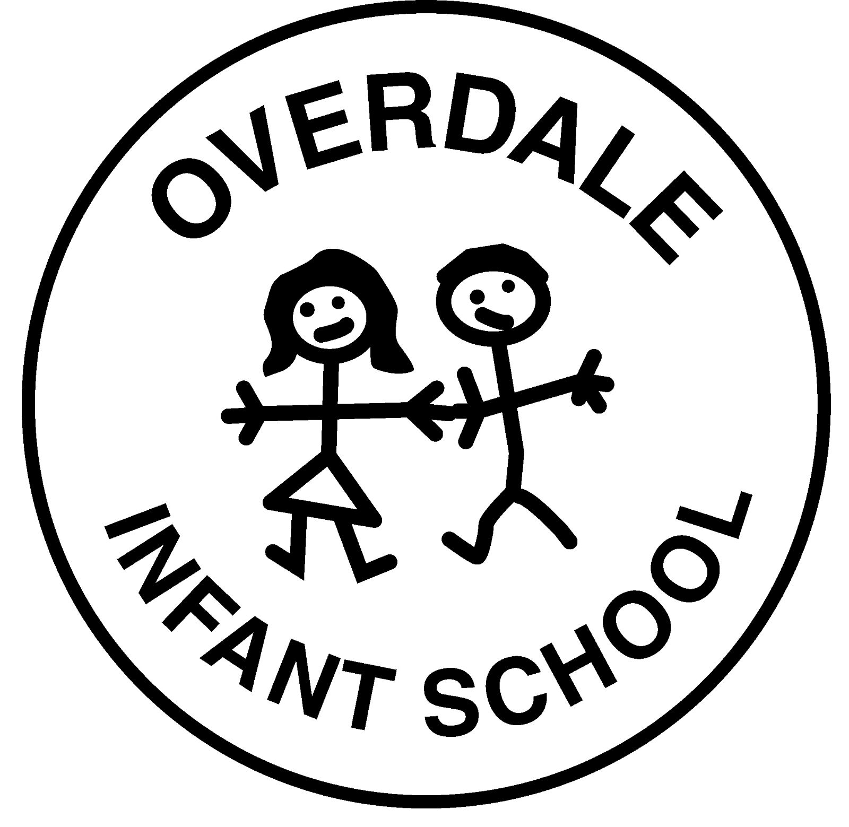

Physical Intervention Policy

Policy Review Date: | April 2022 |  | Headteacher – Hayley Holmes | Signature
Ratified by Governing Body:
Chair of Governors - Daniel Routledge |  |  | Signature

The Legal Framework
Under s. 93 Education and Inspections Act 2006, all members of school staff have a legal power to use reasonable force on and off school premises where the member of staff has lawful control, or is in charge, of the pupil concerned. The decision on whether or not to physically intervene is down to the professional judgement of the member of staff concerned and has to be judged on a case-by-case basis.
93 Power of members of staff to use force.
(1) A person to whom this section applies may use such force as is reasonable in the circumstances for the purpose of preventing a pupil from doing (or continuing to do) any of the following, namely—
(a)committing any offence,
(b)causing personal injury to, or damage to the property of, any person (including the pupil himself), or
(c)prejudicing the maintenance of good order and discipline at the school or among any pupils receiving education at the school, whether during a teaching session or otherwise.

School Values and Policies
The school behaviour policy outlines how staff at Overdale Infant School create and maintain good order and relationships through positive approaches. These approaches are successful for the vast majority of the time. This policy on the use of restrictive physical interventions supplements the main behaviour policy. Both should be read in conjunction with the school SEND policy, the Health & Safety policy, and the Safeguarding policy.
Purpose of this policy
This policy aims to give all members of the school community clear guidance so that any physical intervention that they undertake is carried out in a way that supports the values and principles described above. In particular, it aims to:
- Describe the circumstances in which restrictive physical intervention is an appropriate response.
- Make restrictive physical intervention as safe as possible and relevant for staff and pupils.
- Ensure the safety of staff during restrictive physical intervention is of equal importance to the best interests of pupils and both take priority over the care of property.
- Indicate how staff at school will fulfil their responsibilities in those circumstances.
The Head Teacher will be responsible for ensuring that staff and parents are aware of the policy. She will ensure that any necessary training/awareness-raising takes place so that staff know their responsibilities.
Aims of this policy
The staff at Overdale Infant School recognise that the use of reasonable force is only one of a range of strategies and should be used as a last resort to secure pupil safety and well-being and to maintain good order and discipline. Our policy on physical intervention should therefore be read in conjunction with our Behaviour Policy and Safeguarding Policy. This policy specifically aims:
- That all methods of restrictive interventions are used as infrequently as possible.
- That restrictive interventions when used are used in the best interests of the individual service user/pupil.
- To ensure very reasonable effort is made to minimise risk, harm, or injury to anyone involved and that the need to maintain an individual’s respect, dignity and welfare is maintained.
- That restrictive physical interventions are risk assessed, so that the impact of the restrictive physical intervention will be minimised when key factors are evaluated, and a planned approach is taken to incidents whenever possible.
- To provide adequate information and training for staff so that they are clear as to what constitutes appropriate behaviour and to deal effectively with violent or potentially violent situations.
Physical touch
The staff at Overdale Infant School believe that physical touch is an essential part of human relationships. In our school, adults may well use touch to prompt, to give reassurance or to provide support in PE. To use touch/physical support successfully, staff will adhere to the following principles. It must:
- Be non-abusive, with no intention to cause pain or injury.
- Be in the best interests of the child and others.
- Have a clear educational purpose (e.g. to access the curriculum or to improve social relationships)
- Take account of individuals response to touch.
At our school, the SENCo is responsible for ensuring that relevant staff are aware of any pupil who finds physical touch unwelcome. Such sensitivity may arise from the pupil’s cultural background, personal history, age etc.
Why use physical intervention?
Physical intervention should avert danger by preventing or deflecting a child’s action or perhaps by removing a physical object, which could be used to harm him / herself or others. It is only likely to be needed if a child appears to be unable to exercise self-control over emotions and behaviour.
It is not possible to define every circumstance in which physical restraint would be necessary or appropriate and staff will have to exercise their own judgement in situations which arise. Staff should always act within the School’s behaviour policy, particularly in dealing with disruptive behaviour.
Staff should be aware that when they are in charge of children during the school day, or during other supervised activities, they are acting in loco parentis and should, therefore, take reasonable action to ensure pupils’ safety and well-being.
Failure to physically restrain a pupil who is subsequently injured or injures another, could, in certain circumstances, lead to an accusation of negligence. At the same time staff are not expected to place themselves in situations where they are likely to suffer injury as a result of their intervention.
Alternative strategies
There are some situations in which the need for physical restraint is immediate and where there are no equally effective alternatives (e.g. When a pupil is about to run across a road). However, in many circumstances there are alternatives e.g. the use of assertiveness skills such as:
- The broken record in which an instruction is repeated until the pupil complies.
- The use of a distraction or diversion to interrupt the behaviour long enough for other methods of verbal control to be effective.
- Withdrawal of attention (audience) e.g. if an action such as damage to property is threatened.
- Other techniques designed to defuse the situation, such as the avoidance of confrontation, or use of humour (in these cases the incident can be dealt with later when emotions are no longer running high)
- The employment of other sanctions consistent with the School’s policy on behaviour.
Any pupil who has required a physical intervention within school will have a Positive Handling Plan created for them. This plan will detail the alternative strategies which can be successful with the child. Staff working with children will be familiar with positive handling plans.

What do we mean by ‘physical intervention’?
It is helpful to distinguish between:
Definition |  | Example
Non-restrictive physical intervention is where the pupil can move away from the physical intervention if they wish to. | Either where the child’s movement is not restrictive or where the child is held supportively but such that they will be released immediately should they so wish. | Non-restrictive examples include:  - Physical presence, non-verbal prompts and directions.  - Touch or prompting  - Guiding a person from A to B  - Disengagement.
Restrictive physical intervention is defined as direct physical contact between persons where reasonable force is positively applied against resistance, either to restrict movement or mobility or to disengage from harmful behaviour displayed by an individual. | Prevent, or significantly restrict freedom of movement of an individual. Restrictive interventions generally carry a higher risk and require a greater degree of justification. | Restrictive physical interventions include:  - Escorting and manoeuvring.  - Temporary physical containment or holding.  - Blocking a person’s path.  - Seclusion – isolating a child.  - Full restraint – holding a child.

And between:
Emergency/unplanned interventions | Occur in response to unforeseen events.
Planned interventions | In which staff employ, where necessary, pre-arranged strategies and methods which are based on a risk assessment and recorded in an individual positive handling plan for the pupil.

When is restrictive physical intervention permissible at Overdale Infant School?
Restrictive physical intervention should always be applied as an act of care and control with the intention of re-establishing verbal control as soon as possible and at the same time allowing the pupil to regain self-control. It should never take a from which could be seen as a punishment.
As stated in ‘Use of reasonable force. Advice for Headteachers, staff and governing bodies, July 2013’
Schools can use reasonable force to:
- Remove disruptive children from the classroom where they have refused to follow an instruction to do so.
- Prevent a pupil behaving in a way that disrupts a school event or a school trip or visit.
- Prevent a pupil leaving the classroom where allowing the pupil to leave would risk their safety or lead to behaviour that disrupts the behaviour of others.
- Prevent a pupil from attacking a member of staff or another pupil, or to stop a fight in the playground.
- Restrain a pupil at risk of harming themselves through physical outbursts.
Physical restraint using reasonable force will only be used when all other behaviour procedures have failed and it is obvious that a child is at risk of harming themselves, or others (including adults) or seriously damaging property.
The use of force can be regarded as reasonable only if the circumstances of the particular incident warrant it. The degree of force used must be in proportion to the circumstances of the incident and seriousness of the behaviour or the consequences it is intended to prevent. Any force must always be the minimum needed to achieve the desired result over the shortest possible time.
When physical restraint becomes necessary staff must always:
- Tell the pupil what they are doing and why.
- Use the minimum force necessary.
- Involve another member of staff where possible and alert a member of SLT.
- Tell the pupil what s/he must do for the restraint to be removed (this may need frequent repetition).
- Use simple and clear language.
- Use Team Teach approved restraints following from training wherever possible.
- Relax their restraint in response to the pupil’s compliance.
- Ensure where force is used it is reasonable, proportionate, and necessary within the situation.
Following the use of a physical intervention
Physical intervention often occurs in response to highly charged emotional situations and there is a clear need for debriefing after the incident, both for the staff involved and the pupil. A member of the leadership team should be informed verbally of any incident as soon as possible and all interventions should be recorded on the Leicester City Council Physical Intervention Record and on the school CPOMS system. (Child Protection Online Monitoring System). This record must be signed by a member of the Senior Leadership Team and this member of staff will debrief with the staff member involved.
If any injuries have been sustained by staff or pupils there may be the need for an SO2 document to be completed. Staff will be required to complete the SO2 reporting form and pass this to a member of SLT. An investigation will then take place into how the injury occurred.
The Senior Leadership team will take responsibility for making arrangements for debriefing once the situation has stabilised. An appropriate member of the teaching staff should always be involved in debriefing the pupil involved, where suitable, and any victims of the incident should be offered support, and their parents informed. Following the first physical intervention for a child a positive handling plan will be created. If there are subsequent physical interventions required, the positive handling plan must be reviewed each time.
Parents and carers must always be informed that a physical restraint has occurred. If it is the first physical intervention for a child a telephone call home will be required. If the physical intervention is part of a positive handling plan then parents will have discussed with the school how they would like to be informed of any incidents.
If the behaviour is part of an ongoing pattern, it may be necessary to address the situation through the development of a behaviour plan, which may include an anger management programme, or other strategies agreed by the SENCO. Any behaviour plan should always be discussed and agreed with the parent.
Risk Assessments and Positive Handling Plans
Whenever it is foreseeable that a pupil might require a restrictive physical intervention, then a positive handling plan including a risk assessment must be completed. It is essential that the outcomes of any assessment are made known to all relevant staff and other parties such as parents/carers. The assessment process is the same as for assessing any other form of risk and should be documented on the agreed school format.
When writing a positive handling plan:-
- Involve relevant agencies who may have an involvement with the individual, and their family members.
- Involve key people such as health professionals, social workers, specialist challenging behaviour nurse, psychologist etc. where necessary.
- Identify behaviours and settings that result in harm or damage from past incident reports/records.
- Determine how likely an incident needing restrictive physical intervention is to occur.
- Identify the degree of potential harm/damage resulting from not intervening.
- Document the agreed management strategies and the risk levels.
- If risks of intervening remain high risk, seek specialist advice and support.
- Agree review date and monitor that the protocols and management strategies are working effectively.
- Communicate the outcome of the risk assessment and management strategies/protocol to all relevant parties.
- Implement necessary training if training needs are identified.
When the need for restrictive physical intervention is identified, it is important that appropriate steps are taken to minimise the risks to staff and pupils. Adequate staff must be available to safely complete any holding and restraint that is undertaken as part of a planned strategy.
It is essential that following any intervention positive handling plans are reviewed. It may be necessary to call a formal review meeting and revise the documents with the support of other professionals. When reviewing the plan, it is important to review trends, personality dynamics, factors surrounding the incident, what happened in the days and hours beforehand to look for triggers or contributing factors.
Restrictive physical intervention will only be considered if other behaviour management options have proved ineffective or are judged to be inappropriate (or in an emergency situation?). Before deciding to intervene in this way, staff will weigh up whether the risk of not intervening is greater than the risk of intervening. Any actions will be carried out with the child’s best interests at heart. Physical intervention will never be used to punish a pupil or cause pain, injury, or humiliation.
Staff are not expected to intervene physically against their better judgement nor are they expected to place themselves at unreasonable risk. In such circumstances, they must take steps to minimise risks. For example, by removing other pupils and calling for assistance.
How staff might intervene
When a restrictive physical intervention is justified, staff will use ‘reasonable force’. This is the degree of force ‘warranted by the situation’. It will ‘be proportionate to the circumstances of the incident and the consequences it is intended to prevent’. Any force used will always be the minimum needed to achieve the desired result and for the shortest amount of time.
Staff will:
- Use the minimum amount of force for the minimum amount of time.
- Avoid causing pain or injury; avoid holding or putting pressure on joints; in general hold long bones.
- Never hold a pupil face down on the ground or in any position that might increase the risk of suffocation.
During an incident the member of staff involved will tell the pupil that his or her behaviour may be leading to restraint. This will not be used as a threat or said in a way that could inflame the situation. Staff will not act out of anger or frustration. They will try to adopt a calm, measured approach and always maintain communication with the pupil. Acceptable methods of restrictive physical intervention are as demonstrated in training outlined by local authority officers. In an emergency, staff must summon assistance by sending the nearest responsible person to the nearest class teacher (permanent staff) or the school office, whichever is deemed the most appropriate at the time and place of the incident. A member of the Senior Leadership Team must be informed that restrictive physical intervention is taking place as soon as it is safely possible.
Once a child has needed a physical intervention a positive handling plan will be created. This plan will aim to reduce the likelihood of the need for restrictive physical intervention as well as describing how such intervention will be carried out if necessary. This plan will be discussed with parents/carers and reviewed regularly following future physical interventions.
Information, Instruction and Training for staff
It is the responsibility of the Head Teacher and Senior Leaders to identify the information, instruction and training required to ensure staff can safely employ restrictive physical intervention strategies and techniques where they may need to implement these strategies on a planned basis or potentially in an emergency situation. Training provided to staff should be to the level they are identified as requiring. Training staff in skills they will never use is not necessary and the skills are soon lost. Staff involved in use of planned interventions must have suitable training, for their own safety and that of the pupil.
Training in the use of restrictive physical interventions must be recorded and refreshed in accordance with the training provider’s accreditation scheme. It is the responsibility of those purchasing training to ensure that the training provider is competent, has suitable accreditation and that staff undertaking the training will be assessed as to their competency. Training provided must cover the use of Primary/Active and Secondary/Reactive control strategies as well as the physical techniques and should be suitable for the environment and pupils it will be employed upon. It is not suitable to provide staff with physical intervention techniques without putting its use into appropriate context.
Any training regarding Restrictive Physical Intervention and associated practises should be carried out by accredited organisations. This will ensure that training is facilitated by suitably qualified, professional trainers with an appropriate background and experience of the services delivered. Commissioners of such training must ensure that the physical techniques that staff will be taught have been medically risk assessed to ensure that they are not adverse or painful in their application.
Dress Code
Where staff may be involved in the application of restrictive physical interventions must implement adhere to:-
- Wear suitable clothing that allows freedom of movement.
- Wear sensible low heel footwear.
- Not wear any jewellery and/or piercings that could cause injury.
- Ensure that fingernails are kept short to prevent scratching injuries to service users/pupils when implementing any physical interventions.
Infection Control
Since the nature of aggression and violence can be unpredictable, there is a risk to staff of contamination from bodily fluids because of injury. These risks may be as a result of biting, scratching, self-harm causing bleeding etc. In order to minimise risk, staff must cover any open wounds e.g. cuts/skin lesions and with an appropriate adhesive dressing.
During any pandemic or viral outbreak where appropriate staff will wear face coverings to protect themselves from contamination and will wash and sanitise hands following an physical intervention.
Complaints Procedure
A clear physical intervention policy, adhered to by all staff and shared with parents, should help to avoid complaints from parents. In the event of a dispute about the use of force by a member of staff there may be an investigation, either under disciplinary procedures or by the Police and social services department under child protection procedures.
If child protection procedures are not appropriate the complaint will be dealt with in accordance with the school’s complaints policy. It is our intention to inform all staff, pupils, parents and governors about these procedures and the context in which they apply.
Key Accountabilities Principals
Senior Leadership Team
- Implement the practises detailed within this policy.
- Ensure that the use of planned restrictive physical intervention is risk assessed and management strategies clearly documented on the pupil’s individual care plan.
- Inform employees how to report and record the use of restrictive physical interventions and ensure that these reports are reviewed and monitored regularly.
- Assess training requirements for employees and where training needs are identified ensure that suitable training is provided and refreshed at appropriate intervals.
- Seek specialist advice when necessary, to ensure that use of restrictive physical intervention is used as a last resort and employees use primary and secondary controls to manage behaviour, so reducing the need for the use of restrictive physical interventions.
- Ensure that employees involved in the use of restrictive physical interventions receive suitable debriefing and support following an incident.
- Communicate at the planning stages, during the development of management strategies and during the reviewing process with service users, their family/carers and in the case of children the person with parental responsibility.
- Report on the use of restrictive physical intervention with pupils to their parents/carers.
- Ensure that consent for the use of restrictive physical interventions has been gained and is clearly documented.
Employees
- Familiarise themselves with the risk assessments and management strategies for the use of restrictive physical interventions and report any use.
- Attend training provided and then use the skills gained in line with training guidelines and in accordance with risk assessments and management strategies whenever possible.
- Ensure that any physical force used in the workplace is reasonable, proportionate to the risk and with suitable justification.
- Report any concerns regarding management of pupil behaviour or the use of restrictive physical interventions to a line manager immediately.

